#### JQ6500 voice module instruction manual V1.4

1. ****Description:****   
   JQ6500 is a serial chip to provide MP3, the perfect integrated MP3, WMV hard decoding. At the same time software support TF card driver, support the computer directly update spi flash content, support FAT16, FAT32 file system. Through a simple serial command to complete the playback of the specified music, and how to play music and other functions, without cumbersome the underlying operation, easy to use, stable and reliable is the biggest feature of this product. In addition, the chip is also a deep customization of products, designed for fixed voice playback in the field of low-cost solutions.  
     
   ****2. Features****   
   1. Support sampling rate (KHz): 8 / 11.025 / 12/16 / 22.05 / 24/32 / 44.1 / 48  
   2. 24-bit DAC output, dynamic range support 90dB, SNR support 85dB  
   3. Full support FAT16, FAT32 file system, the largest support 32G TF card, support 32G U disk, 64M bytes NORFLASH  
   4. A variety of control mode, parallel port control mode, serial port mode, AD button control mode  
   5. Broadcast language spots, you can pause the background music is playing  
   6. The audio data sorted by folder, up to 100 folders, every folder can be assigned 1000 songs  
   7. 30 level adjustable, 10 EQ adjustable  
   8. You can plug in SPI flash, connect the computer can display spi flash letter to update the content;  
   9. Can be controlled through the microcontroller serial port to play the specified music;  
   10. In the key mode, you can play mode selection: can be interrupted, can not be interrupted, single cycle, large cycle;  
   Can be interrupted: that is, in the process of playing, press the button will interrupt the current state to perform the new;  
   Can not be interrupted: that is, in the process of playing, press any button is invalid, until the end of the play to play the current effective;  
     
   ****3. Application:****   
   1. Car navigation voice broadcast  
   2. Road transport inspection, toll station voice prompts;  
   3. The train station, bus station security check voice prompts;  
   4. Power, communications, financial business hall voice prompts;  
   5. The vehicle into the channel verification voice prompts;  
   6. Border check channel voice prompts;  
   7. Multi-channel voice alarm or device operation to guide voice;  
   8. Electric sightseeing car safe driving voice notice;  
   9. Mechanical and electrical equipment failure automatic alarm;  
   10. Fire alarm alarm;  
   11. Automatic broadcast equipment, regular broadcast.  
     
   ****4. Basic parameter:****

|  |  |
| --- | --- |
| ****Name**** | ****Parameter**** |
| MP3 file format | 1. supports all bit rates 11172-3 and ISO13813-3 layer3 audio decoding |
| 2.Sampling rate support(KHZ):8/11.025/12/16/22.05/24/32/44.1/48 |
| 3. Support Normal, Jazz, Classic, Pop,Rock and other sound effects |
| UART Interface | Standard serial port, TTL level, baud rate can be set |
| Input voltage | Power supply is at 3.2V-5V, 4.2V Power supply is the best |
| Rated current | 20ma |
| Size | Standard DIP16 package |
| Operating temperature | -40℃~70℃ |
| Humidity | 5% ~ 95% |

1. 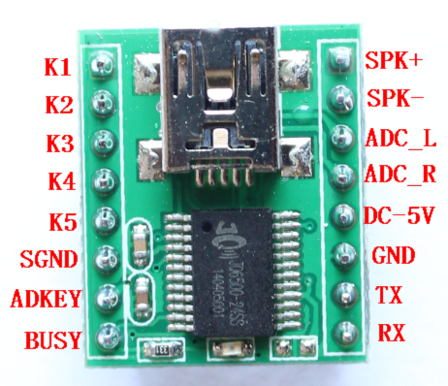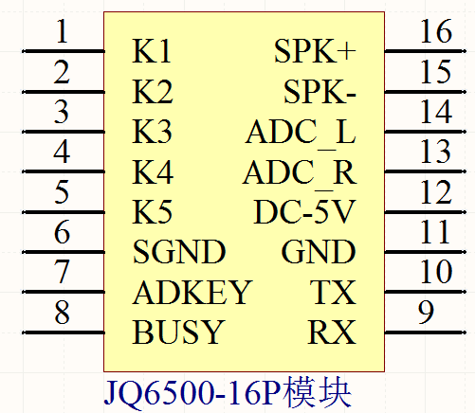****Module Pin Description****

|  |  |  |  |
| --- | --- | --- | --- |
| Pin number | Pin name | Function | Remarks |
| 1 | K1 | Corresponding to the first paragraph of audio | Trigger to play the first audio of the ground |
| 2 | K2 | Corresponding to the second paragraph of audio | Trigger playback of the second audio to the ground |
| 3 | K3 | Corresponding to the third paragraph of audio | Trigger playback of the third audio to the ground |
| 4 | K4 | Corresponding to the 4th audio | Trigger playback of the 4th audio to the ground |
| 5 | K5 | Corresponding to the 5th audio | Trigger playback of the 5th audio to the ground |
| 6 | SGND | GND | Power GND |
| 7 | ADKEY | AD port |  |
| 8 | BUSY | Play indicator | High lever |
| 9 | RX | UART serial data input |  |
| 10 | TX | UART serial data output |  |
| 11 | GND | GND | Power GND |
| 12 | DC-5V | Power input | Can not exceed 5.2V |
| 13 | ADC_R | Audio output right channel | Drive headphones, amplifier |
| 14 | ADC_l | Audio output left channel | Drive headphones, amplifier |
| 15 | SPK- | Speaker + | Directly drive 1W/8R speakers |
| 16 | SPK+ | Speaker - |  |

1. ****Wiring Diagram Example****

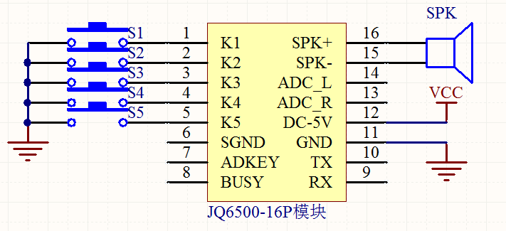

1. ****Control Method Description****
   1. ****Button interface****

**The chip we use is the AD button, which replaces the traditional matrix keyboard connection. The advantage of this is that it makes full use of the MCU's increasingly powerful AD function. The design is simple and not simple. Our chip defaults to 2 AD ports and 20 buttons for resistance distribution. If used in strong electromagnetic interference or strong inductive or capacitive load, please refer to our “Precautions”.**

**ADKEY resistance function: 0R PLAY, 3.3K next song, V+, 6.2K previous song, V-, 9.1K mode test switching;**

1.** 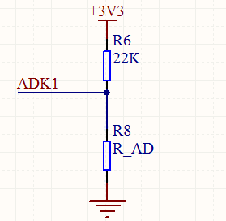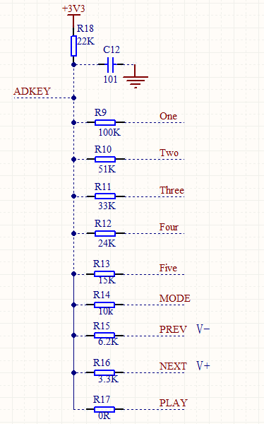, reference schematic**

****Button mode description****

**The pulse can be repeated: press the button to start playing, no matter how long it is played, and press the button during the playback to interrupt the currently playing voice and execute the new command.**

**The pulse cannot be repeated: press the button to start playing, no matter how long it is played, the button is invalid during the playback, and the button is valid after the playback.**

**The level is not holdable and can be cycled: press the button to start playing, and keep playing until it is pressed. After releasing, the current voice will stop playing after playing.**

**The level can be cycled: press the button to start playing, keep pressing it all the way, and release it to stop playing immediately.**

* 1. ****Communication format****

|  |  |  |
| --- | --- | --- |
| Support asynchronous serial communication mode, accept commands sent by host computer through serial port       Communication standard: 9600 bps       Data bits : 8       Check digit :none       Flow control : none | | |
|
|
|
| **Format: $S VER Len CMD Feedback para1 para2 checksum $O** | | |
|  |  |  |
| $S | Start bit 0x7E | Each command feedback starts with $, which is 0x7E |
| Len | Number of bytes after len | Len + CMD + para1 + para2 |
| CMD | Command word | Indicates specific actions, such as play/pause, etc. |
| para1 | Parameter 1 | Query data high byte (such as song number) |
| para2 | Parameter 2 | Query data low byte |
| $O | End position | End bit 0xEF |
|  |  |  |

****For example, if we specify playback, we need to send: 7E 004 003 0001 EF, red for** the first number, 01 for the first, 02 for the second So we start at 01;**

**The data length is 4, and these 4 bytes are [04 03 0001]. No start, no end.**

**Combined play:**

**Send [7E 04 03 0001 EF] [7E 04 03 0002 EF] [7E 04 03 0002 EF] [7E 04 03 0001 EF] [7E 04 03 0001 EF] [7E 04 03 0003 EF], then play the first song, the second song and the third song in a row, which can be combined up to 10 times, and stop after playing.**

* 1. ****Communication instruction****
     1. ****Directly sent instructions, no need to return parameters:****

|  |  |  |
| --- | --- | --- |
| **Detailed CMD (instruction)** | **Corresponding function** | **Parameter (16 bits) and corresponding instruction format** |
| 0x01 | Next song | [7E 02 01 EF] |
| 0x02 | Previous song | [7E 02 02 EF] |
| 0x03 | Specified track (NUM) | 0-65535, SPI (0-200)  [7E 04 03 00 01 EF] means playing the first piece of music  The red font is the number of segments played. You can change it. |
| 0x04 | Volume + | [7E 02 04 EF] |
| 0x05 | Volume - | [7E 02 05 EF] |
| 0x06 | Specified volume | 0-30[7E 03 06 15 EF] Red font is the volume range from 00 to 1E |
| 0x07 | Specify EQ (0/1/2/3/4/5) | Normal/Pop/Rock/Jazz/Classic/Base  [7E 03 07 01 EF] Red font can be changed from 00 to 05 |
| 0x09 | Specify device (0/1/2/3/4) | U/TF/AUX/SLEEP/FLASH  [7E 03 09 01 EF] Red font can be changed from 00 to 05 |
| 0x0A | Go to sleep -- low power | Pause playback  [7E 02 0A EF] |
| 0x0C | Chip reset | [7E 02 0C EF] |
| 0x0D | Play | [7E 02 0D EF] |
| 0x0E | Pause | [7E 02 0E EF] |
| 0x0F | Upper and lower folder switching | 1 next folder. 0 previous folder  [7E 03 0F 00 EF] red font can be described as 00 01 |
| 0x10 | Reserved |  |
| 0x11 | Loop | 0 1 2 3 4 (ALL FOL ONE RAM ONE_STOP)  [7E 03 11 00 EF] The red font is 00 01 corresponding to the corresponding mode, 00 means all loops, 01 means single loop; for example: to play the second song, first send 7E 03 11 01 EF and then send 7E 04 03 00 02 EF |
| 0x12 | Specify folder file playback | 01 01 (Front 01 refers to the document behind the folder 01) Note 1  【7E 04 12 01 01 EF】  That is, the 01 file in the 01 folder is played. |
|  | Insert function | This function must exist both flash and TF card, that is, the TF card stores music, and the flash stores voice. When playing music, a voice can be inserted. After the voice is played, the music is played from the disconnected point. Operation mode: When playing the music of the TF card, first convert to flash, that is, send the command: [7E 03 09 04 EF], then send the corresponding flash voice segment: [7E 04 03 00 01 EF], use BUSY detection After the playback, send the command to the TF card, that is, send the command: [7E 03 09 01 EF], and then send the play command: [7E 02 0D EF] |

****For example, the next song, send: 7E 02 01 EF****

****For example, the previous song, send: 7E 02 02 EF****

****For example, play, send: 7E 02 0D EF****

* + 1. ****Querying the parameters of the system:****

|  |  |  |
| --- | --- | --- |
| CMD command details (query) | Corresponding function | Description and command format |
| 0x40 | Return error, request resend |  |
| 0x42 | Query current status | Play, stop, pause three states  [7E 02 42 EF] |
| 0x43 | Query current volume | [7E 02 43 EF] |
| 0x44 | Query current EQ | The return value is 012345 (Normal/Pop/Rock/Jazz/Classic/Base)  [7E 02 44 EF] |
| 0x45 | Query current play mode | Return value 0 1 2 3 4 Correspondence (ALL FOL ONE RAM ONE_STOP)  [7E 02 45 EF] |
| 0x46 | Query current software version | [7E 02 46 EF] |
| 0x47 | Query the total number of files in the TF card | [7E 02 47 EF] |
| 0x48 | Query the total number of files in UDISK | [7E 02 48 EF] |
| 0x49 | Query the total number of files in FLASH | [7E 02 49 EF] |
| 0x4B | Query the current track of the TF card | [7E 02 4B EF] |
| 0x4C | Query the current track of UDISK | [7E 02 4C EF] |
| 0x4D | Query the current track of FLASH | [7E 02 4D EF] |
| 0x50 | Query the current play time | [7E 02 50 EF] |
| 0x51 | Query the current total playtime of the song | [7E 02 51 EF] |
| 0x52 | Query the name of the current play song | The return value is the song name (not supported by SPIflsh)  [7E 02 52 EF] |
| 0x53 | Query the total number of folders in the current folder | [7E 02 53 EF] |
|  |  |  |

**Example: Read the volume size and send [7E 02 43 EF] to directly return the volume (16 bits)**

**ADKEY resistance function: 0R PLAY 3.3K next song, V+ 6.2K previous song, V- 9.1K mode test switch,**

**Remark 1 The folder name in the U disk and TF card must be 01 02.............99 The file name in the folder must be 001 002 003...........**

* + 1. ****Description of the voice file in the memory:****

**\* The sound file must be in MP3 format.**

**\* The name of the file is not limited, but [00 01] mentioned in the above instruction refers to the first MP3 file, and [00 03] refers to the third MP3 file. The order is based on the order in which the memory is loaded.**

****7.3.4 The length of voice that can be loaded in three types of memory:****

**A, JQ6500 module SPI FLASH capacity and audio time length conversion table: (unit: S)**

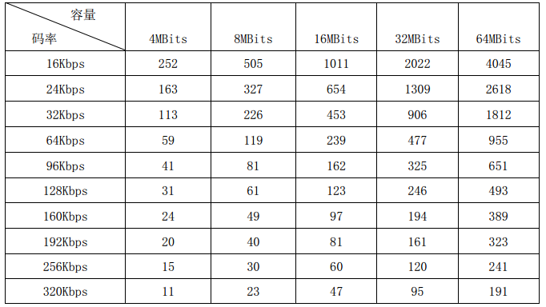

**B. Several voices will be pre-installed in the factory module for testing. Generally, a 128kbps 32M MP3 file can be installed for about 4 minutes (a song).**

**C, TF card (SD card), U disk, capacity is supported within 32G. The loading voice time calculation standard is: 1M Byte = 1 minute. So 1G capacity = 1024 minutes = 17 hours.**

1. ****Update Voice Description****

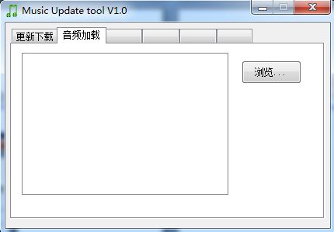**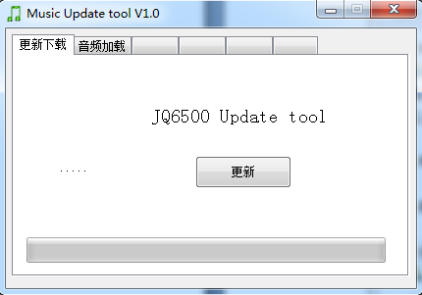Connect the module's MINI USB to your computer, open "My Computer" and double-click "CD Drive..."**

The computer will release a PC software that updates the content.

Check "Audio Loading" - click "Browse",



**Select the audio you want to put in and click "Open".**

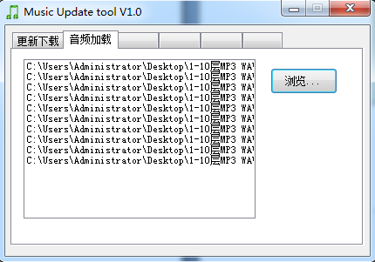

**Audio is added to the host computer software,**

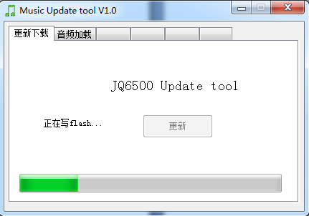

**Check the "Update Downloads" tab and click Update.**

v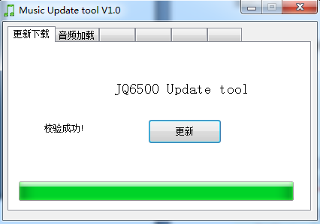



**As shown in the figure, it means that the voice has been downloaded to the spi flash of the module.**

1. ****Reference Circuit****

**Serial communication interface, baud rate default 9600, can be modified according to customer requirements**

**Interface circuit of external AD button, the function of the button can be customized according to customer requirements**

**External mono amplifier reference circuit**

* 1. ****Serial interface****

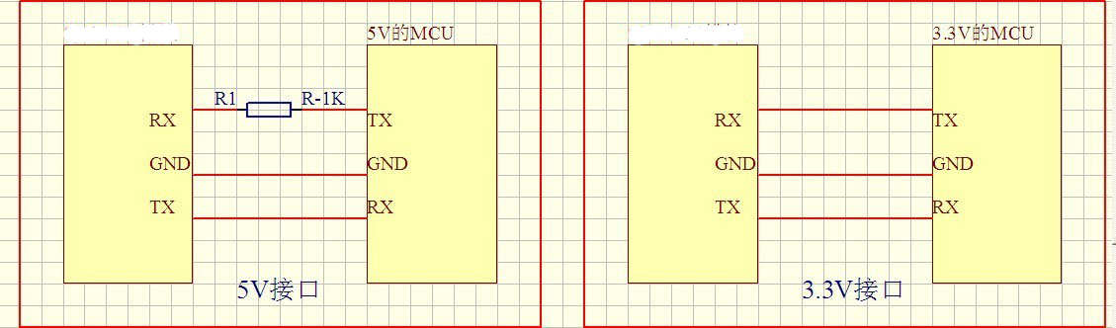

The serial port of the chip is a TTL level of 3.3V, so the default interface level is 3.3V. If the system is 5V. Then it is recommended to connect a 1K resistor in series with the serial interface of the serial port. This is sufficient for general requirements. If it is used in strong electromagnetic interference, please refer to the “Precautions”. The chip has been tested normally in both 5V and 3.3V systems and everything is fine. All are in direct connection, and there is no string of 1K resistors.

* 1. ****External mono amplifier****

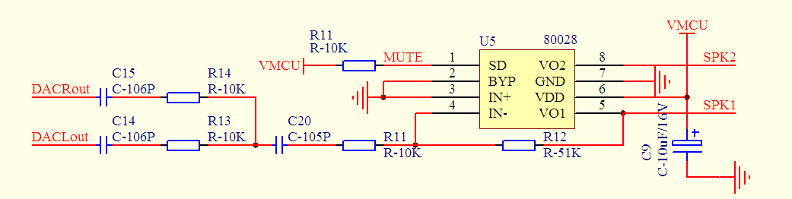

Here we use 8002 power amplifier, please refer to IC's datasheet for specific parameters. It is enough for general occasions. If you are looking for higher sound quality, please find the right amplifier for yourself.

* 1. ****External earphone circuit****



Here, R4 and R5 are limiting resistors to prevent the external sound source from being too large (Vp-p maximum is 3.0V), which affects the stability of the system. C1 and C2 are DC blocking capacitors, preventing the DC level of the external source from affecting the internal chip. Bias; R2 and R3 reserved resistors for high power amplifier design

1. ****JQ6500-16P module package drawing****

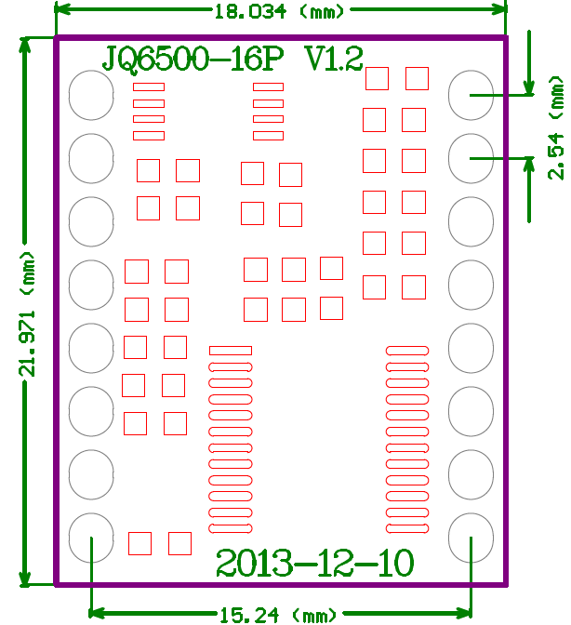

1. ****JQ6500-16P module schematic****

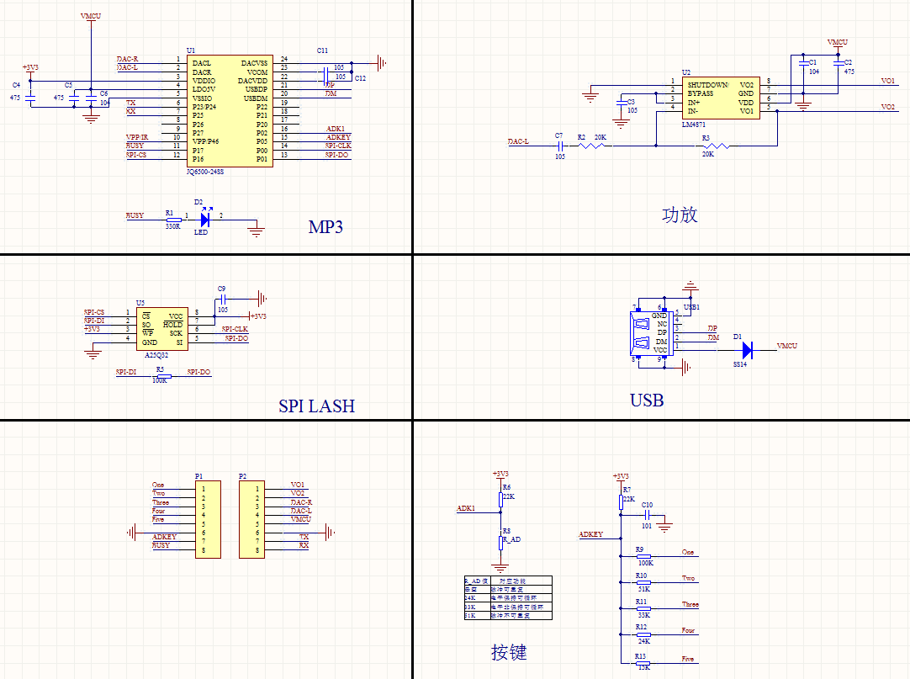

1. ****Precautions****

|  |  |  |  |  |  |  |
| --- | --- | --- | --- | --- | --- | --- |
| IO input characteristics | | | | | | |
| Symbol | Parameter | Min. | Typical | Max. | Unit | Test Conditions |
| VIL | Low-Level Input Voltage | -0.3 | - | 0.3*VDD | V | VDD=3.3V |
| VIH | High-Level Input Voltage | 0.7VDD | - | VDD+0.3 | V | VDD=3.3V |
| IO output characteristics | | | | | | |
| Symbol | Parameter | Min. | Typical | Max. | Unit | Test Conditions |
| VOL | Low-Level Output Voltage | - | - | 0.33 | V | VDD=3.3V |
| VOH | High-Level Output Voltage | 2.7 | - | - | V | VDD=3.3V |
|  |  |  |  |  |  |  |

**1. The external interface of the chip is 3.3V TTL level, so in the design of the hardware circuit, please pay attention to the level conversion problem.**

**In addition, in the environment of strong interference, please pay attention to some protection measures of electromagnetic compatibility, GPIO adopts optocoupler isolation, increase TVS, etc.**

**2. The value of the button of ADKEY is in accordance with the general use environment. If it is in the environment of strong inductive or capacitive load, please pay attention to the power supply of the chip. It is recommended to use separate isolation power supply, and then be equipped with magnetic beads and inductors for power supply. Filtering, we must ensure that the input power supply is stable and clean as much as possible. If it is not guaranteed, please contact us to reduce the number of buttons and redefine the wider voltage distribution.**

**3. Serial communication, in the general use environment, pay attention to the level conversion. If the interference environment is strong, or the long-distance RS485 application, please pay attention to the isolation of the signal, and design the communication circuit in strict accordance with the industrial standard. Can contact us, we provide design reference**